Rutgers Postdoctoral Individual Development Plan (IDP)

To be completed first by the postdoctoral researcher and then shared with the faculty mentor. Please see detailed instructions on how to complete this form on our website.

Postdoctoral Researcher’s Name:
School & Department:
Rutgers Email:
Personal Email:
Annual Review Date:
Appointment Start Date:
Appointment End Date:
Faculty Mentor Name:
Postdoc’s Signature:
Faculty Mentor’s Signature:

Part 1. Reflect of long-term and short-term career goals.

- What are your long-term career interests? (i.e., research academia, industry, teaching, business, public policy, science writing, etc.):

- What skills do you have that you think will allow you to succeed in that career?

- What is one step you want to take towards your career goals? (i.e., internship, publications, grant application, teaching, workshops, courses, informational interviews, job search, etc.)

- Have you built professional relationships with mentors outside of your lab who can help advance your research and career interests and goals? List the name of potential mentors you would like to connect within the next year.

- If your career interests or goals have changed in the past year, please describe the motivation for the change.

- What are your current goals during your postdoctoral training?

Part 2. Progress Review:

Research Training in the Past Year

- In one sentence, please state your research project goals for the previous year:

- Please provide a brief overview of your research project and major accomplishments in the past year in no more than 250 words (half page, 12 point font, and single space). If an IDP was completed last year, reflect on which goals were met, and which goals were harder to meet:

- List of publications:

- List of patents (if applicable):

- List of fellowships and grants written/applied for/received. If received, please include entire funding periods:

- List of honors & awards—including professional society presentation awards or travel awards, etc.:

- National or other professional meetings attended.
Please indicate meeting title, date, oral, or poster presentation:

- Seminar Presentations (title, department):

- New areas of research or technical expertise acquired in past year:

Career Development Training in the Past Year

- Have you attended any of the professional career development workshop offerings and/or individual career advising sessions at Rutgers? (OPA events, iJOBS events, OASIS, RCN, INSPIRE, etc.) If so, specify which workshops you attended and what you learned.

- Please indicate any teaching activity. Include course lectures (department, course name) or lab sections (section title, supervised/unsupervised by a faculty member):

- Please indicate any oversight or mentoring of graduate, undergraduate, summer students and/or research staff:

- Please indicate any clinical activity (if applicable):

- Committee or other service activity, if applicable (indicate if you held an office):

- Other professional activities not identified above:

- Other social outreach activities (community, etc.) with professional relevance:

Part 3. Plans for the Upcoming Year:

- Research project goals.
Please briefly indicate how the goals may change in the coming year:

- Anticipated publications. Indicate projected titles:

- Anticipated meeting or workshop attendance:

- Fellowship or other funding applications planned. Please indicate the name of the award:

- Other professional training (course work, workshop, mentoring program, iJOBS, INSPIRE, OPA individual career advising sessions, OPA professional development workshops, etc.):

- What skill sets and training, if any, must you acquire to achieve your career and research goals?

- When do you anticipate beginning a job search? If within one year of the IDP meeting, discuss an exit strategy.

- Please indicate if other issues affect your job search:

Part 4. Advisor’s comments: (A half page is acceptable).

Dear advisor, please include other relevant information and suggestions in support of the postdoctoral fellow’s research and career goals. This section may include any or all of the following:

- What areas have this postdoc excelled in during their time in the lab?

- What areas (skills or accomplishments) need to be strengthened before a successful job search?

- Is this postdoc currently on-track to meet his or her career goals?

Mosaic of Mentors Map
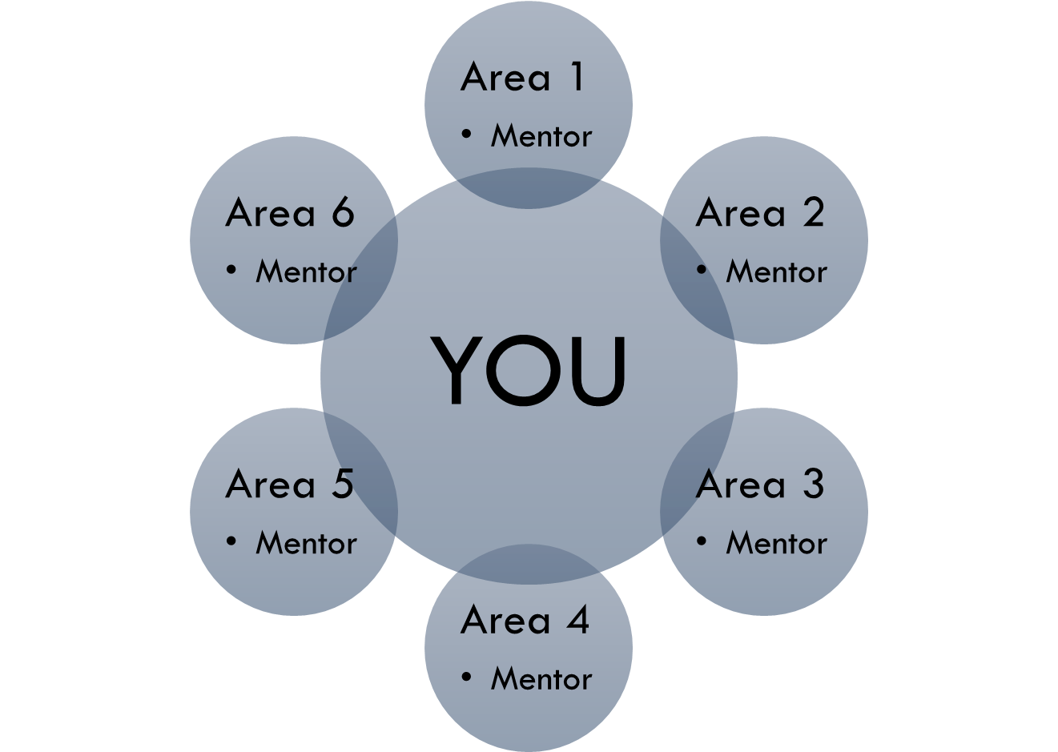

We all need different kinds of support for different aspects of our careers. One individual cannot alone fulfill all the mentoring support that another individual needs. Using a mosaic of mentors’ map provides a framework for mentoring and empowers you to develop your own mentoring network comprised of multiple individuals. As a result, you are trained to be proactive, take ownership, and drive the mentoring relationships.

Steps to complete your Mosaic of Mentors Map

- Make a list of areas or skills that need improvement and that you need help with. These could be areas that stood out from completing the self-assessment and Rutgers IDP document.

- Don’t limit your areas of improvement to career goals. Think also of areas in your personal life that need improvement (i.e. wellness, life-work balance, etc.)

- Once you have identified the areas that you need help with, use your Mosaic of Mentors Map to identify which of your mentors you could go to for guidance in that particular area.

- Connect with your mentors and establish the level of help needed. If meetings are necessary, agree on the frequency, location and time of such meetings.
- Be honest with yourself and be proactive. Be the one to schedule the meetings and show up with an agenda to discuss. You can use your IDP or SMART goals as a guideline for the discussion as well.

Areas I need help with: | Mentors

